Our similarities and differences
For this task, each circle represents one of our countries (Norway, Turkey and Belgium). In each circle, fill in what is unique about our countries and in the middle, fill in what we all have in common. You could mention things such as types of food we eat, our climates, how we live, music, culture and our countries’ focus on sustainability. Try to fill in at least 3 points in each section of the Venn-diagram.
TÜRKIYE
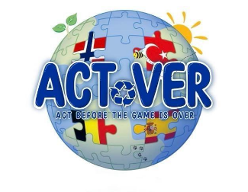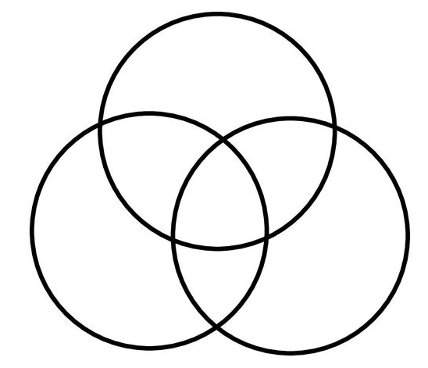
BELGIUM
NORWAY

