Games and Stories - Act Before the Game is Over
Today we are spending three hours at Bergen Public Library. During those three hours you will be creating games and books about the environment, climate change and climate action. You will be placed in groups of 4-5 people.

Half of the groups will make a game using the platform Genially, while the other half will make a digital book using the platform Storyjumper. Groups who finish will design climate messages/slogans using the platform Canva.
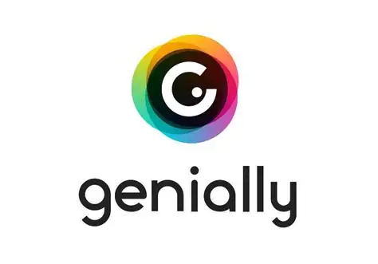

Our program today
09.00-09.15: Introduction of the day
09.15-11.15: Groups create their games and books. If time, groups design climate messages.
11.15-12.00: The groups present their games and books to the other groups.
12.00-12.45: Lunch
12.45-14.30: A sustainability walking tour of Bergen.

